Speech Timer Revision Request

This app will also be used within organizations.
Please create a login function and establish two types of user accounts: administrators and users who can create and edit content.

Please make this timer viewable to event participants (such as speakers).
Please add a feature that allows us to generate QR codes.

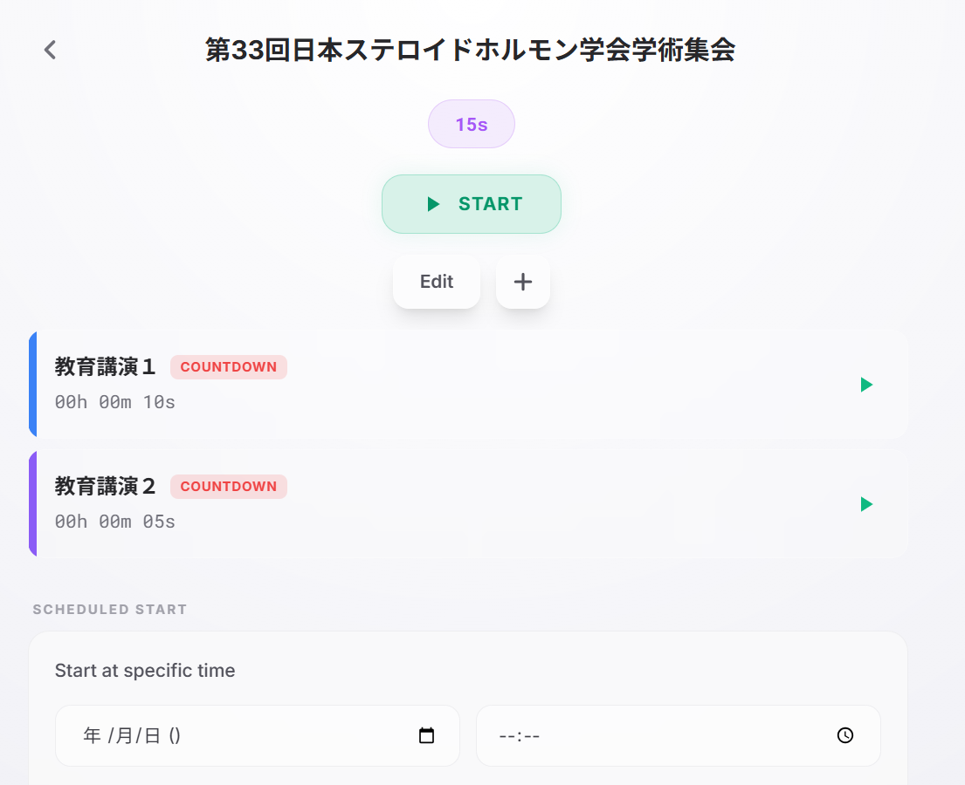

If you scan this QR code, only the timer screen will be displayed; you will not be able to access the edit screen.
If you scan the QR code before the start time, the message “Please wait until the start time” will appear. When the administrator starts the timer, the screen will automatically switch to display the timer screen.
